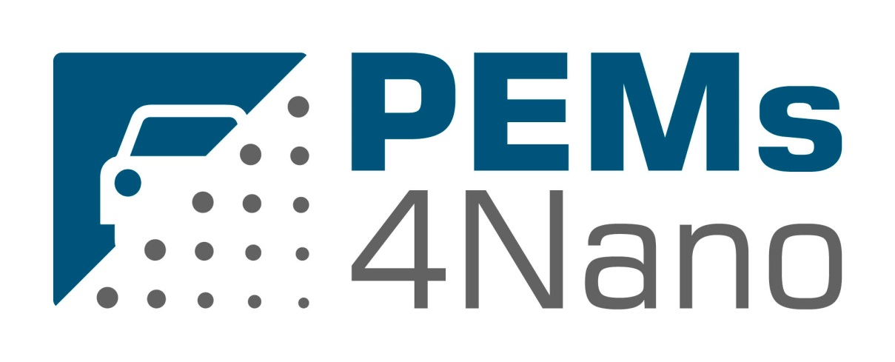
Portable Nano-Particle Emission Measurement System

EUROPEAN COMMISSION
Horizon 2020 | GV-02-2016 | Technologies for low emission light duty powertrains
GA # 724145

Deliverable No. | PEMs4Nano D1.2
Deliverable Title | Report on criteria for project internal impact assessment
Deliverable Date | 2017-03-31
Deliverable Type | REPORT
Dissemination level | Confidential, only for members of the consortium (CO)
Written By | Susanna Paz (IDIADA) | 2017-02-24
Checked by | Rosa Delgado (IDIADA) | 2017-03-27
Approved by | Ian Faye (BOSCH)  Helge Dageförde (BOSCH)  Joel Danzer (HORIBA)  Marcus Rieker (HORIBA) - Coordinator | 2017-03-30  2017-03-31  2017-03-31  2017-03-31
Status | Final | 2017-03-31

Publishable Executive Summary

This deliverable D1.2 consists of the definition of the different criteria that will be used in WP4 – “Implementation of a calibration method for the particle counting systems. Final Validation and Robustness Evaluation under Real Driving Conditions” to assess about the impact of the new technology developed in the PEMs4Nano project to measure Particle Number down to 10 nm.

Some criteria will be defined in this document; these criteria will be related to the calibration procedure, the equipment preparation and the measurement protocol to determine PN down to 10 nm in a laboratory with the new developed PN 10 nm, or on the Real Road with the new developed PEMS PN 10 nm.

Some criteria related to the compatibility of the new equipment with the current technology used in an Exhaust Emission Laboratory and On-Board emissions tests will be defined. Finally, some criteria related the quality validation of the new measurement technology will be defined and a comparison among the different PN measurement technologies will be performed.

IDIADA’s specific view of the criteria that have to be fulfilled by the new developed technologies (PN 10 nm and PEMS PN 10 nm) has been studied.

In order to define these criteria, some reference documents were taken into account:

- Some of the new PN 10 nm requirements will be based on the established PN 23 nm requirements due to their technical similarity, which are defined in the following bibliography:

- European Regulation: Addendum 82: Regulation No. 83 - Annex 4a – Appendix 5
- GTR No. 15: Addendum 15: Global technical regulation No. 15: Worldwide harmonized Light vehicles Test Procedure
- The HORIBA Solid Particle Counting System MEXA-2100SPCS Instruction manual of Installation and Maintenance.

- In the same way, most of the new PEMS PN 10 nm requirements were based on the established PEMS PN 23 nm requirements due to their similarity, which are defined in the following bibliography:

- “European Regulation of Real Driving Emissions (RDE) 2016/46 with an additional Amending Regulation RDE 3th package DRAFT.
- The HORIBA On-board Emissions Measurement System OBS-ONE-PN 23 nm - Instruction manual of Installation and Maintenance was used to set some targets in the PEMS PN 10 nm.

All these defined criteria will be checked during the test campaign performed in WP4 in order to assess the feasibility and robustness of the new measurement equipment and how the measurement technology is with respect to the criterion considered.

The activities performed in this WP4 will consist of a complete empirical testing using the technology developed in the WP2 with the final objective of ensuring its correct operation to measure small particles down to 10 nm. Testing will be based on the standard existing WLTC and RDE procedures.

These criteria are chosen to ensure a comprehensive evaluation of the new measurement technology developed in the PEMs4Nano Project. We have to take into account that the assessment may not be entirely free of subjective judgments.

Acknowledgement

The author(s) would like to thank the partners in the project for their valuable comments on previous drafts and for performing the review.

Project partners:
# | Type | Partner | Partner Full Name
1 | IND | HORIBA | Horiba Europe GmbH
2 | IND | Bosch | Robert Bosch GmbH
3 | IND/SME | CMCL | Computational Modelling Cambridge Limited
4 | IND | TSI | TSI GmbH
5 | HE | UCAM | The Chancellor, Masters and scholars of the University of Cambridge
6 | HE | ULL | Université des Sciences et Technologies De Lille – Lille I
7 | IND | IDIADA | IDIADA Automotive Technology SA
8 | IND | HORJY | Horiba Jobin Yvon S.A.S.
9 | IND/SME | UNR | Uniresearch BV

This project has received funding from the European Union’s Horizon2020 research and innovation programme under Grant Agreement no. 724145.

